**STAT440 Case Study2 Report**

*Zimo Zhu*

*301243686*

**Method**

***Data description***

The data is from Baltimore government website with 2975537 rows and 7 columns.

***Data cleaning***

***Volume reduction***

0.5% of the data were used and two variables were removed

***Missing value***

Using regular expression to regularize the missing value term then dealing with missing value problem by imputation (mice function in mice package).

***Date and time variable***

Since there is a variable contain the date and time of the call, firstly I use str_extract function in stringr package along with regular expression to separate the date and time. Secondly, 12-hour time is being transformed into 24-hour time by applying as.POXISct function. For the date value, using lubridate package function year, month and weekdays can extract the corresponding year, month and weekdays for each observation.

***Data analysis***

During the process of cleaning mess description, I classify those description containing key word like shooting, cutting, stabbing, dead body, knife, gun into the group called violent crime. This kind of crime is much more serious than other, and more weight were put on this kind of call. At the first, I tried two methods to plot the map of Baltimore. The first one is called get_map function (zoom = 12) which is in ggmap package and the second one is called qmap function (source = “stamen”,maptype = “toner”) which is in qmap package. Secondly, use ggplot in ggplot2 package to plot the scatter of the violent crime subset data, and setting the color and group equal to their district. This will give us a pretty good intuition on the location of occurrences of violent crime. By adding a contour plot will make the intuition even better. To compare the occurrences of violent crime in each hour or weekday or month, I add facte_warp at the very end.

Thirdly, using geom_freqpoly will give us the bar plot for violent crime in each hour and weekday and month. Finally, using pie3d function in plotrix package along with aggregate function will give us the 3d pie chart of the proportion of violent crime that occur in each hour, weekday, district and month. Based on these plots, it is easy to provide an evidence-base suggestion on how to provide the public safety.

**Extra Result**

***Overall Trend***

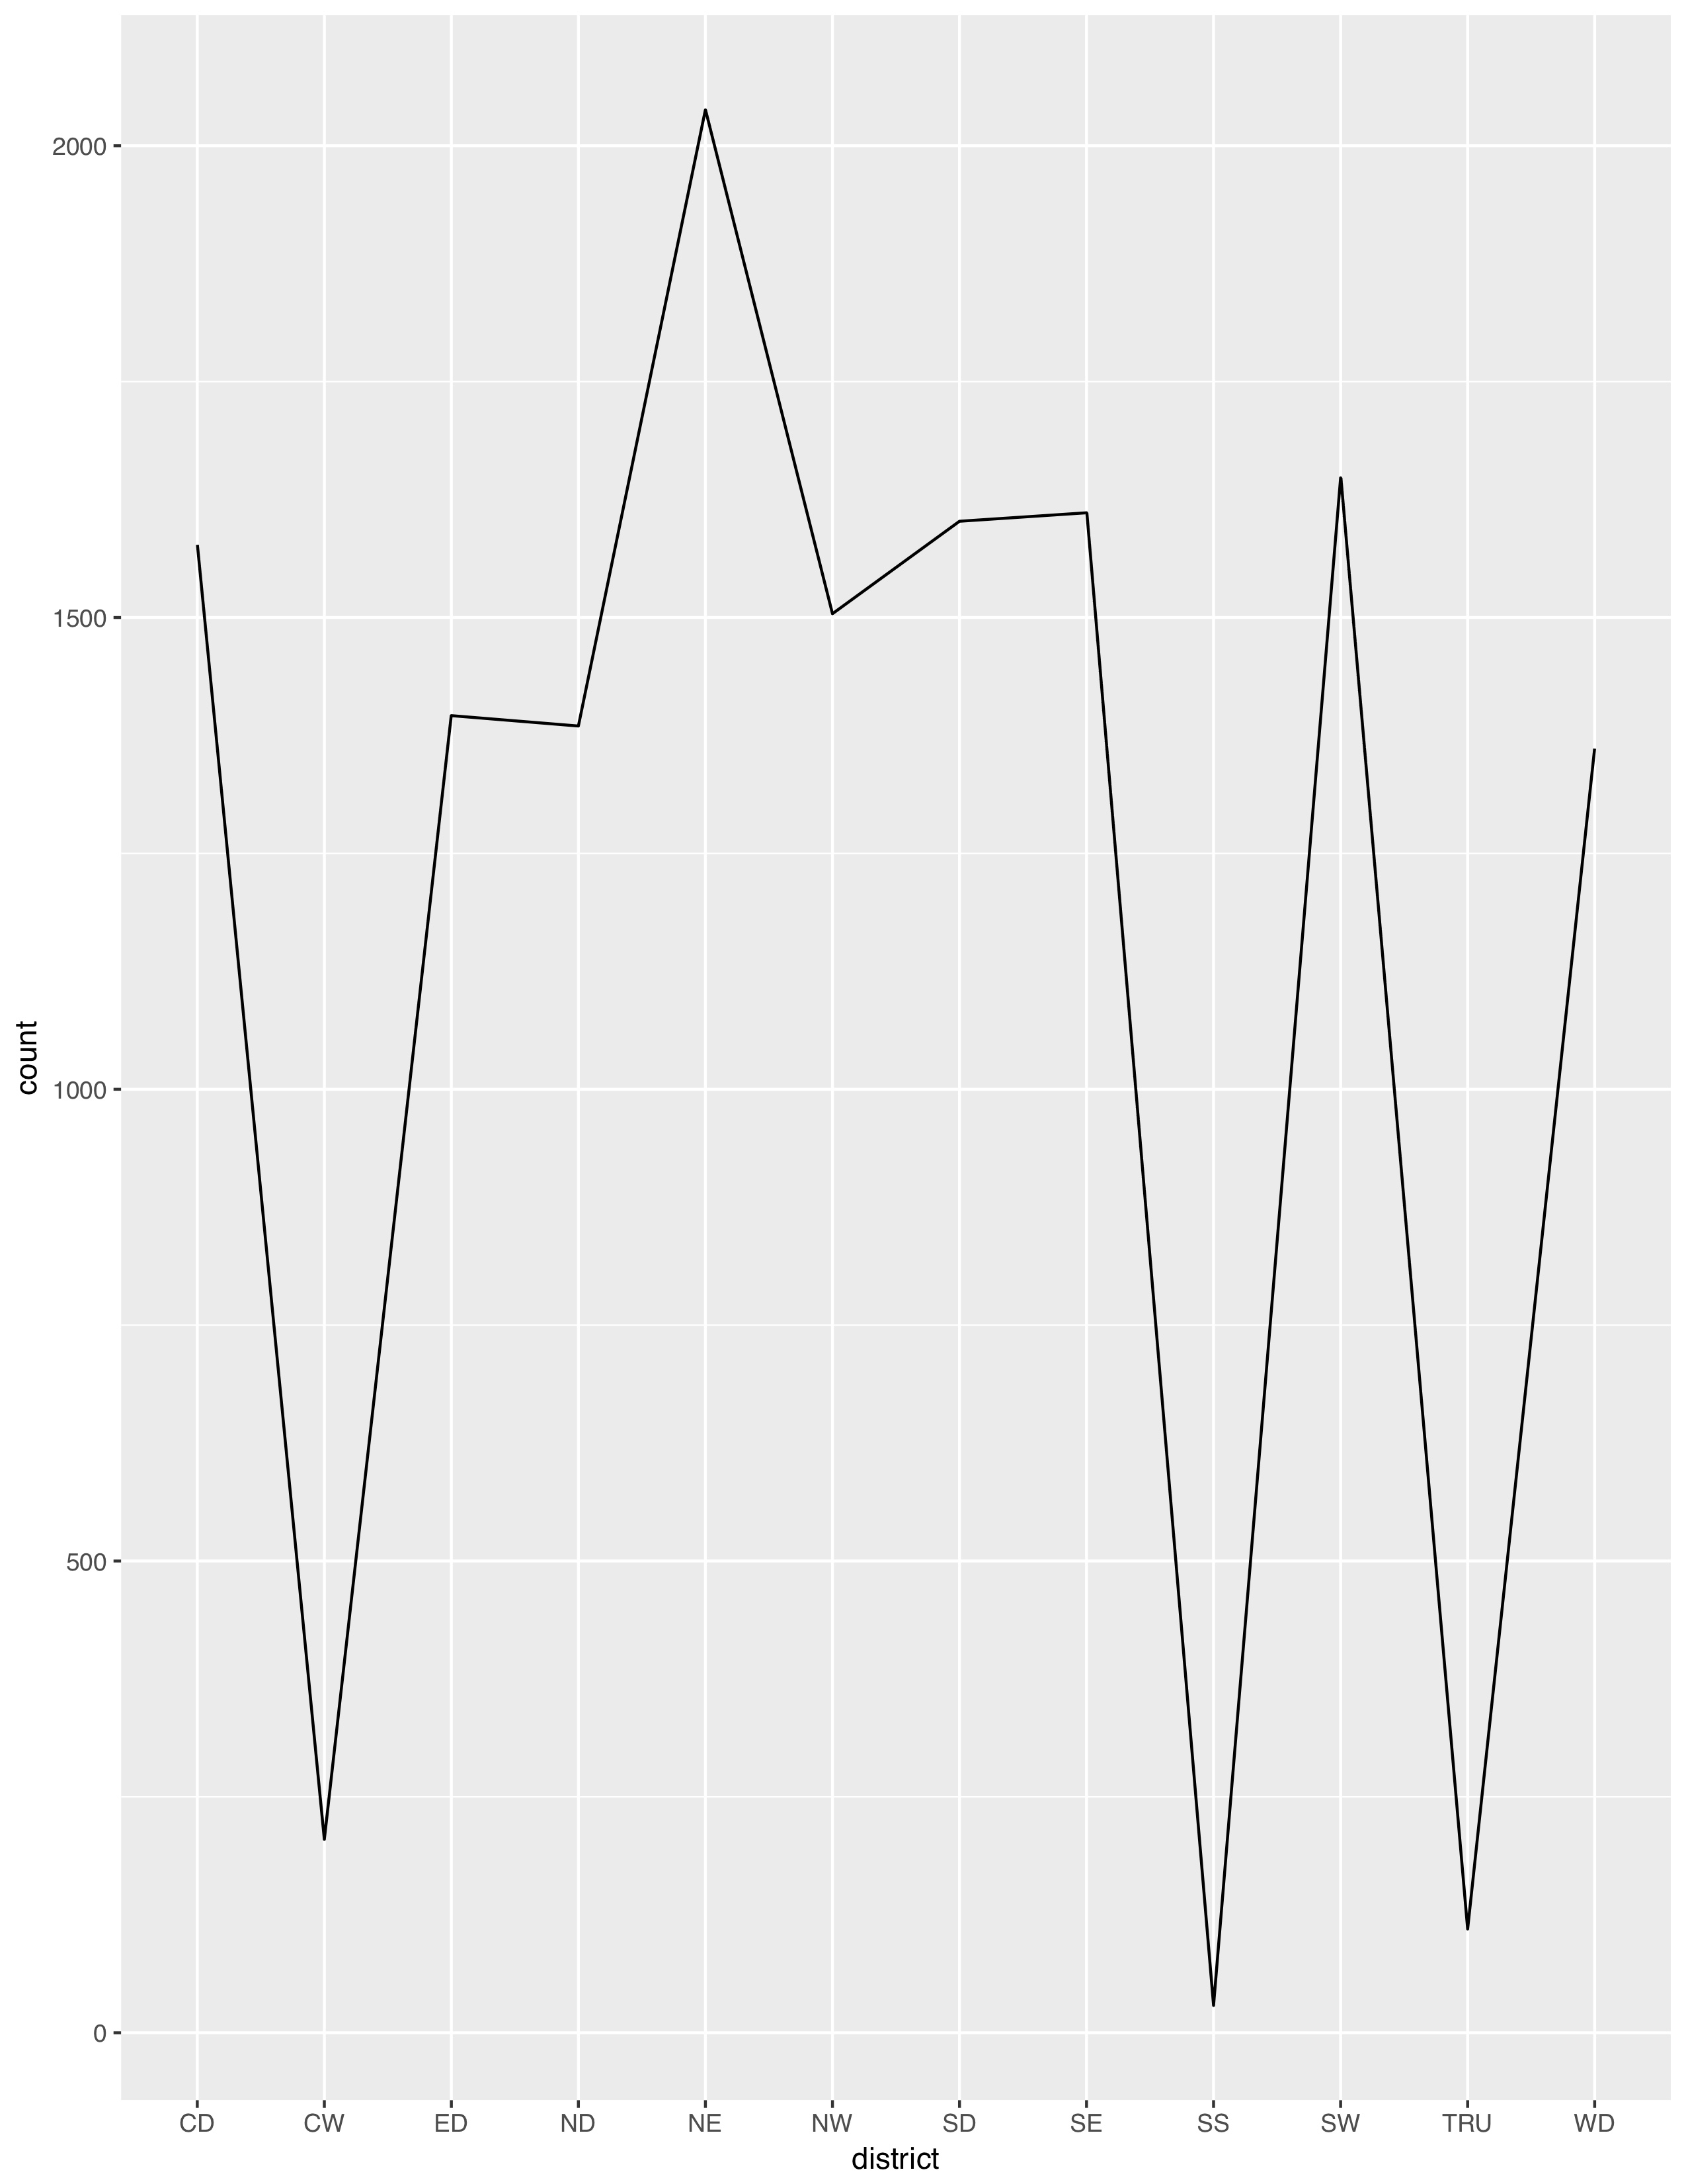 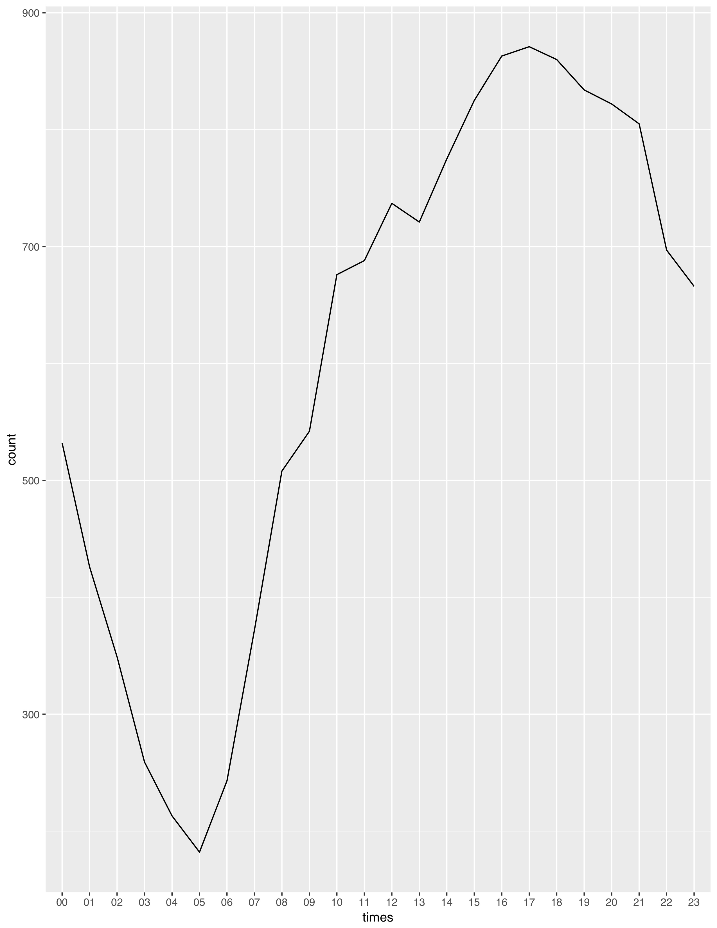 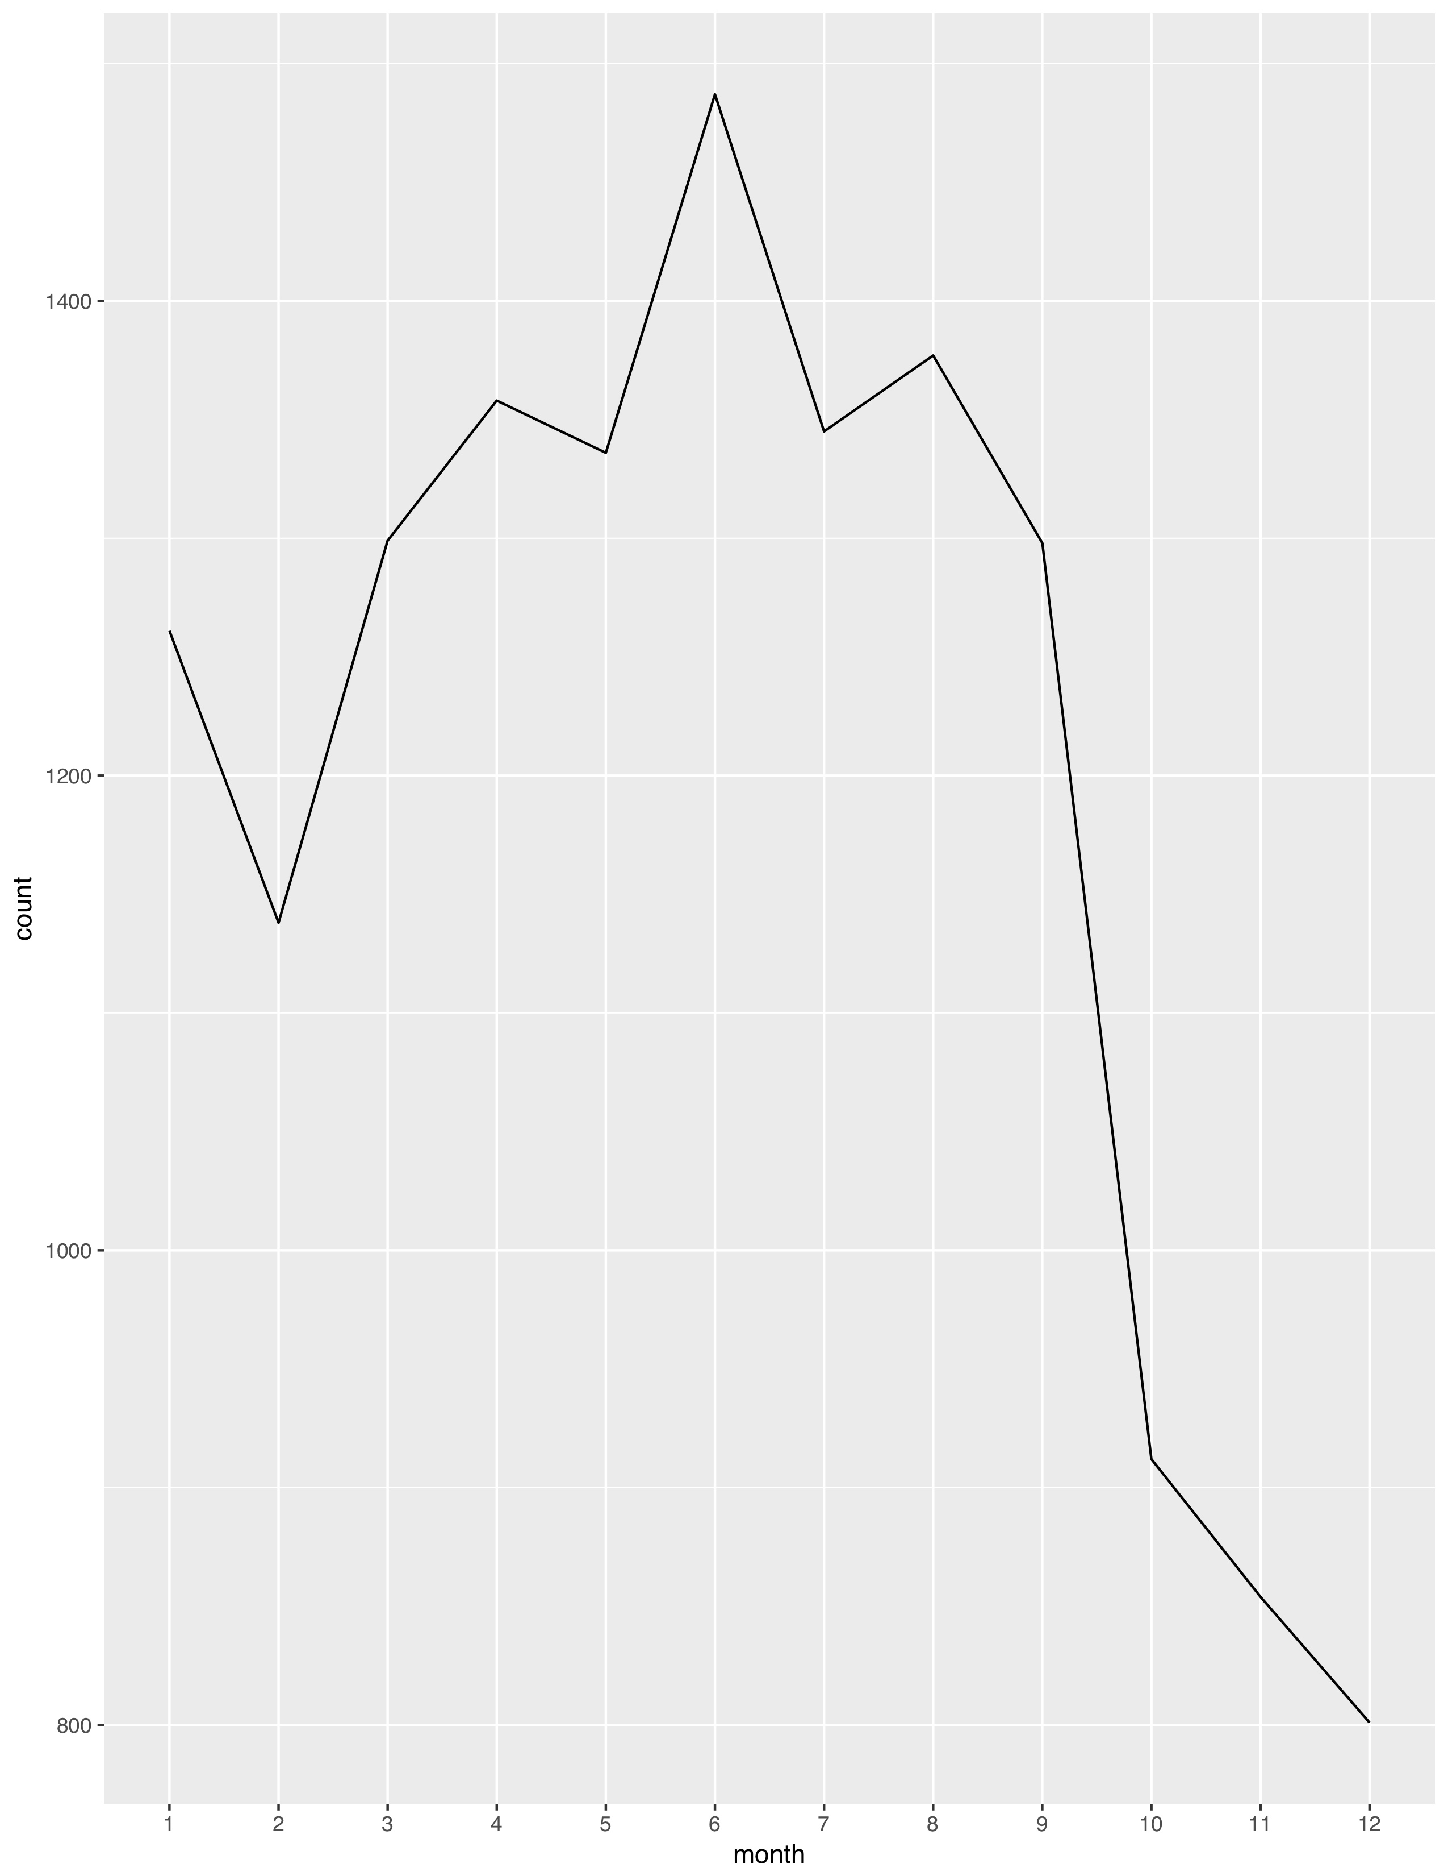

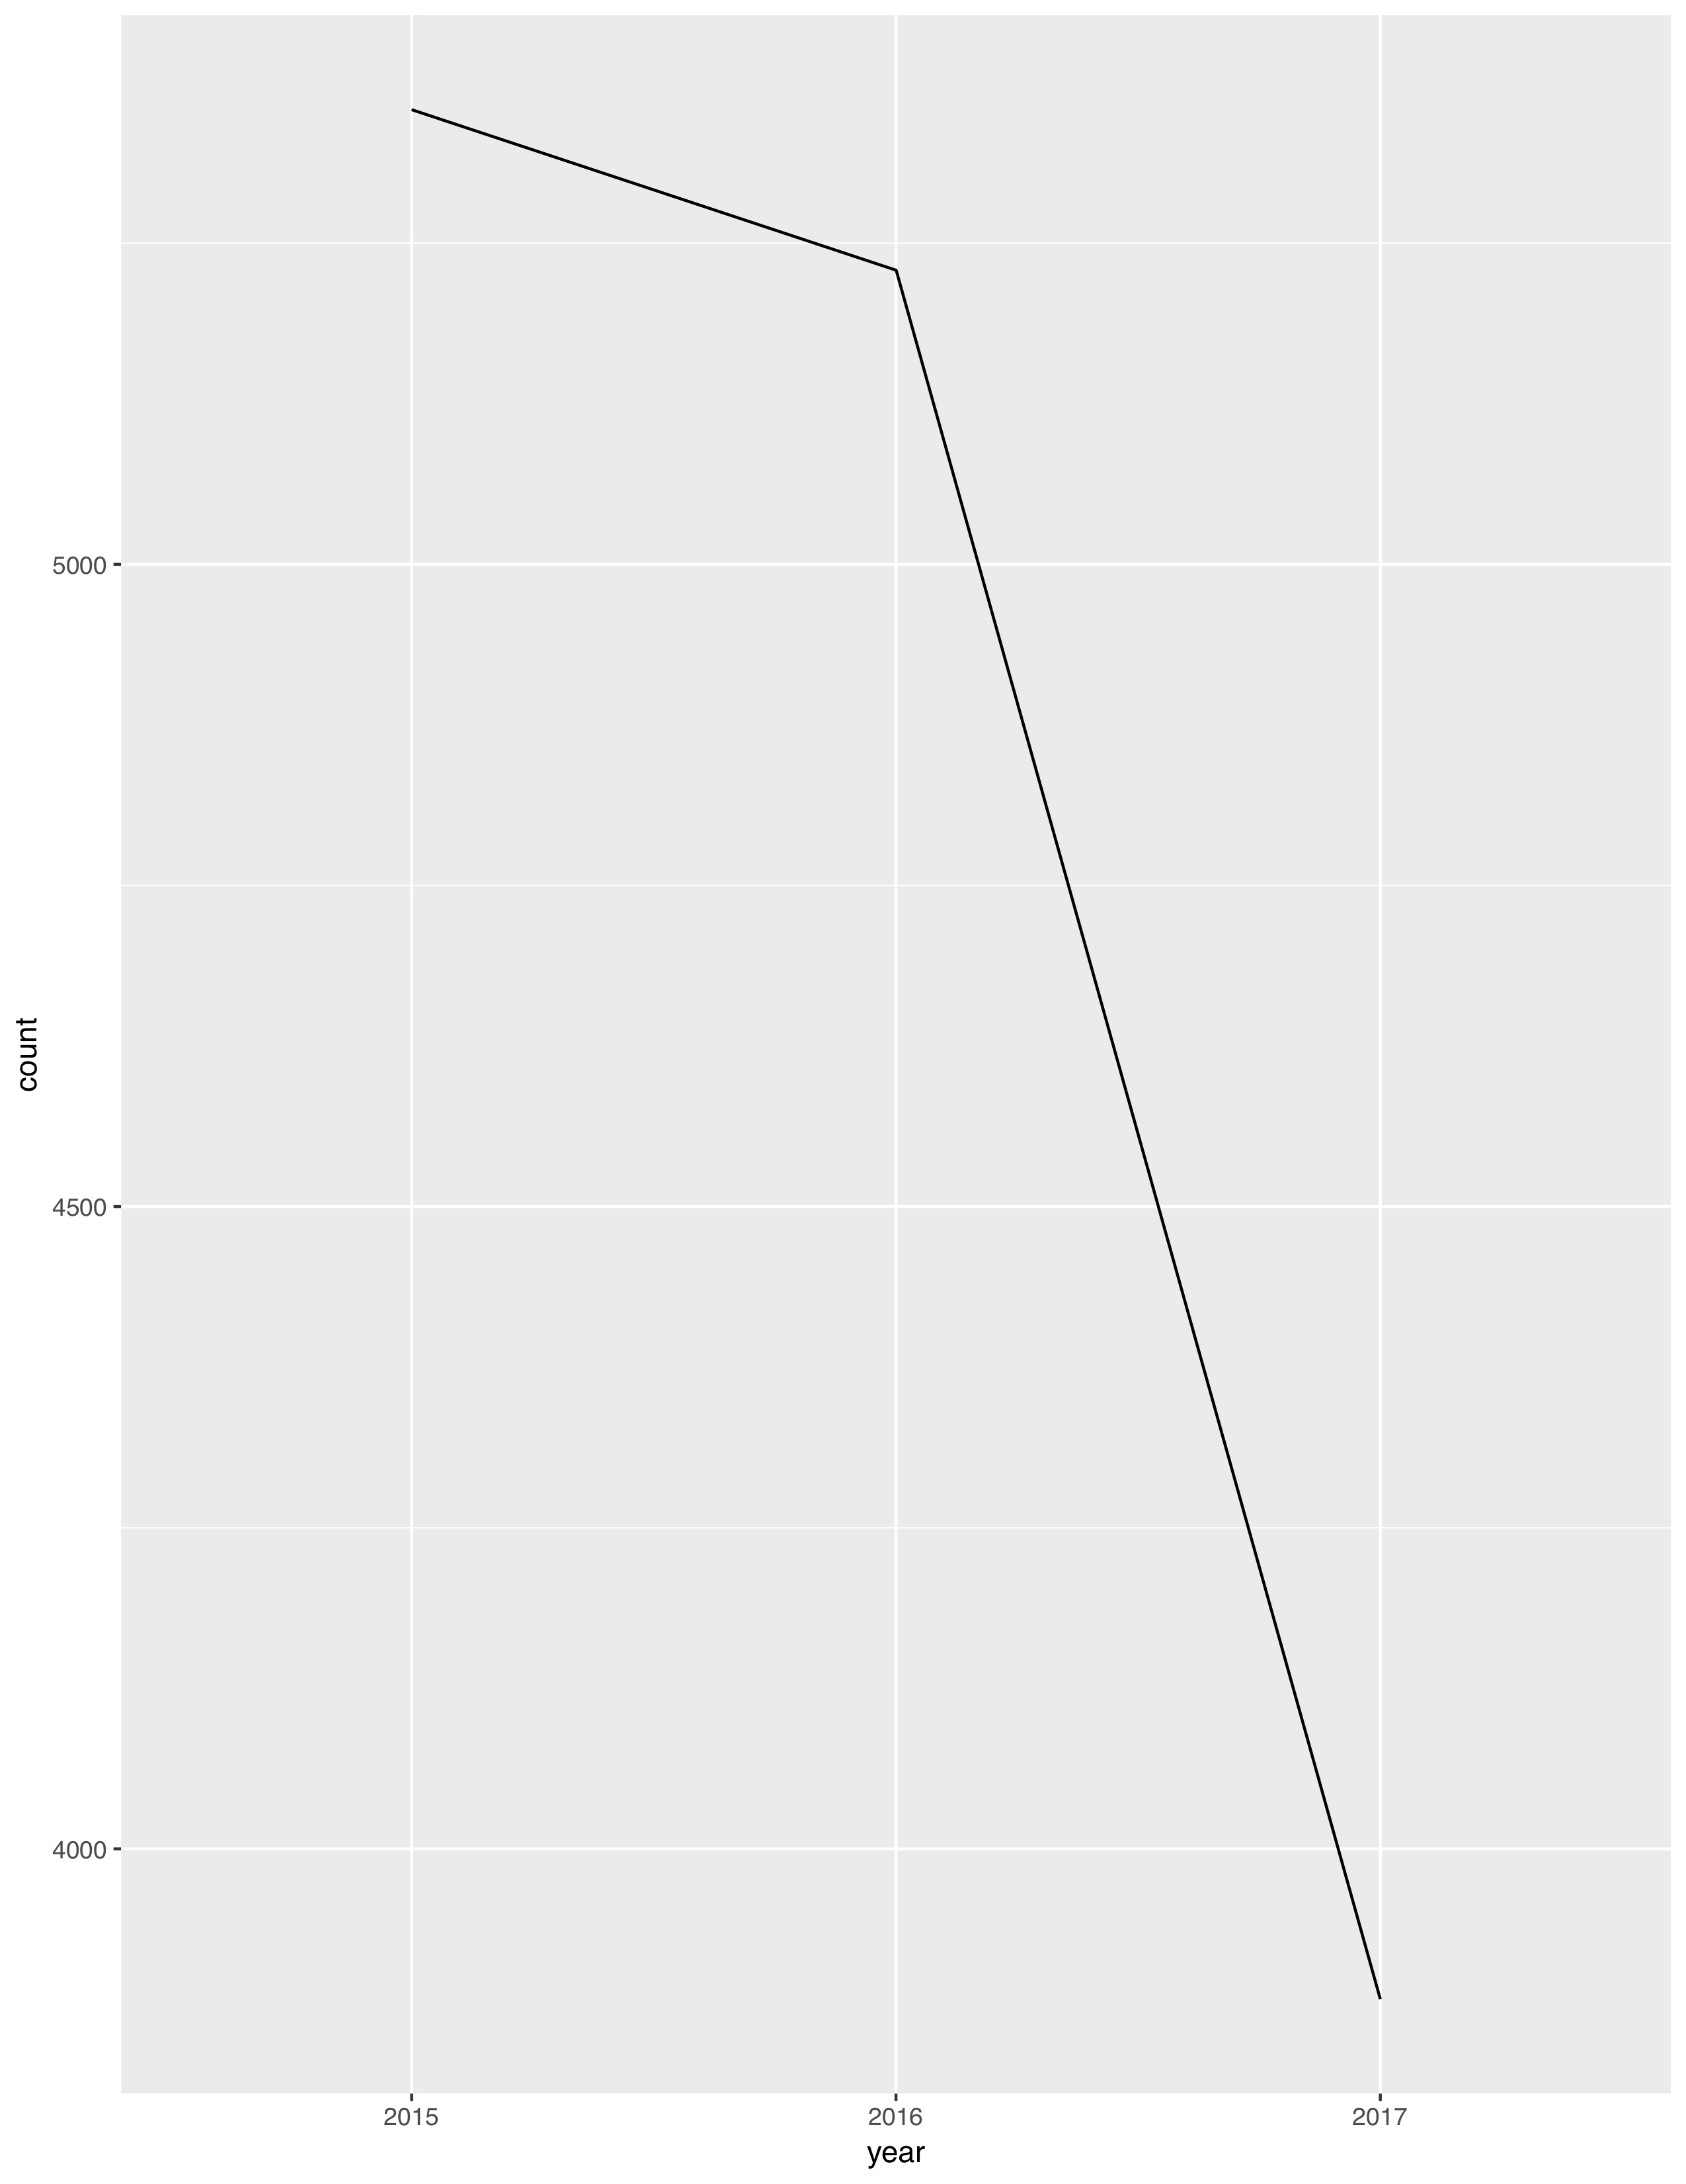

***(overall trend for the total call counts by each district, hour, month and year)***

***Violent Crime analyzes***

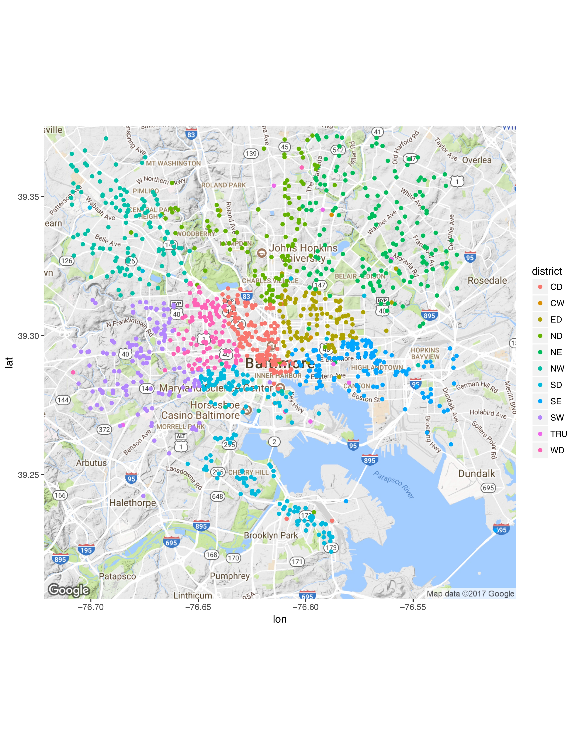 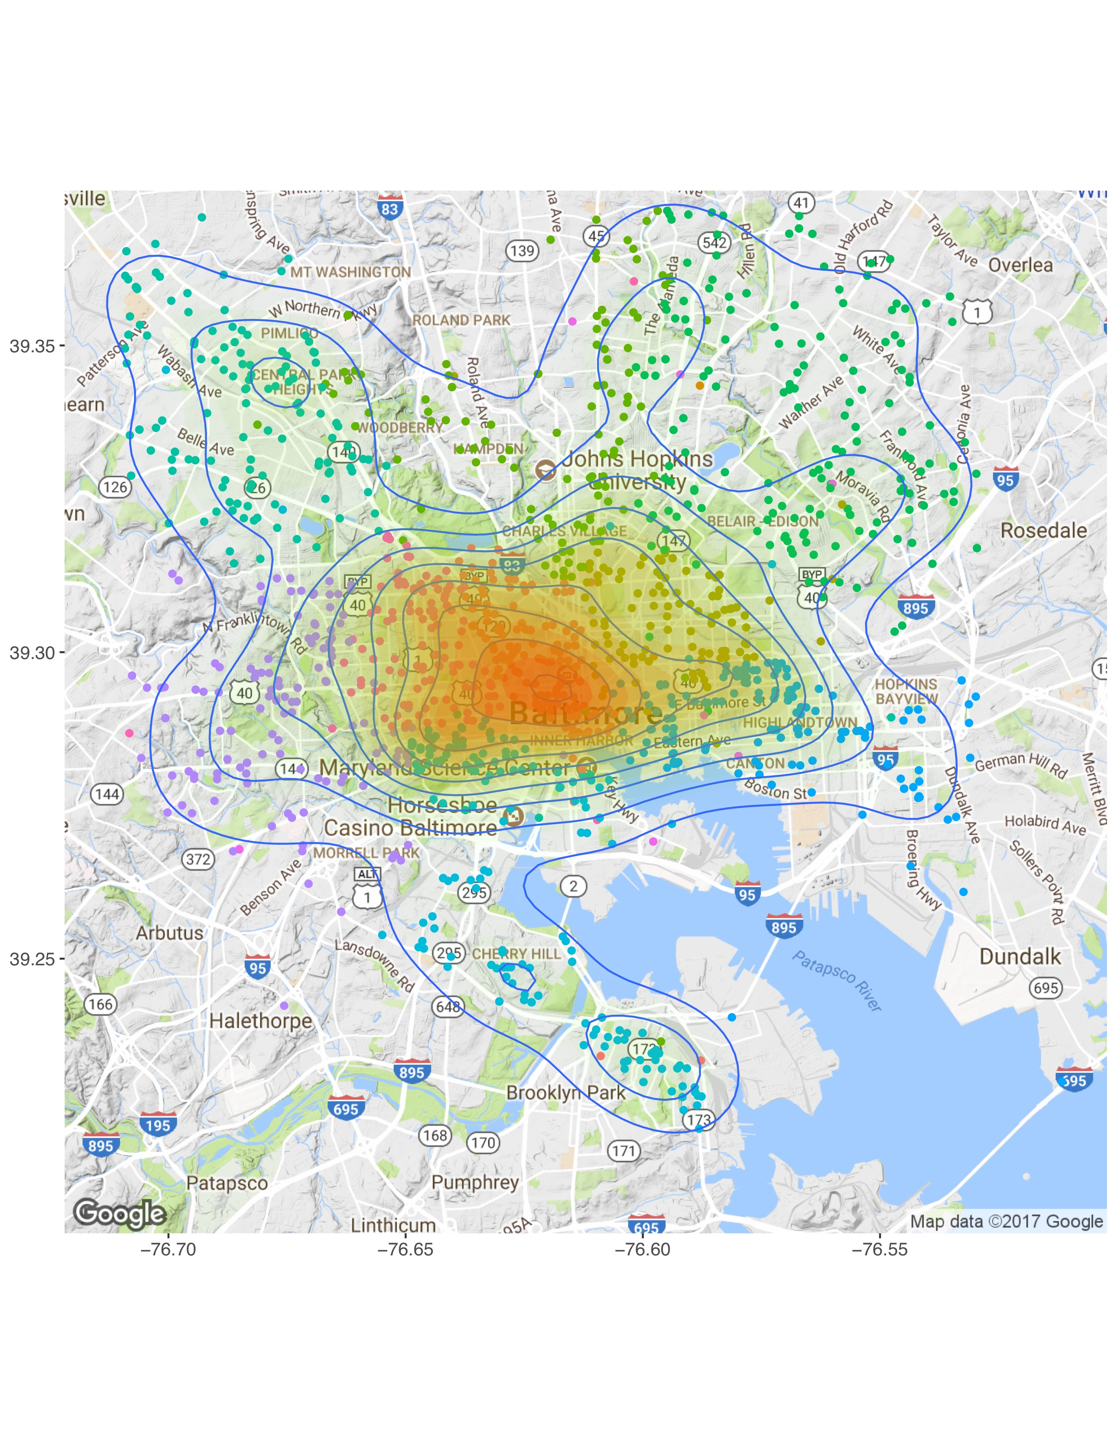

***(location of each call that involving violent crime with/without contour)***

Call density:

High(relatively): district CD and thejunction of district CD, SE and ED

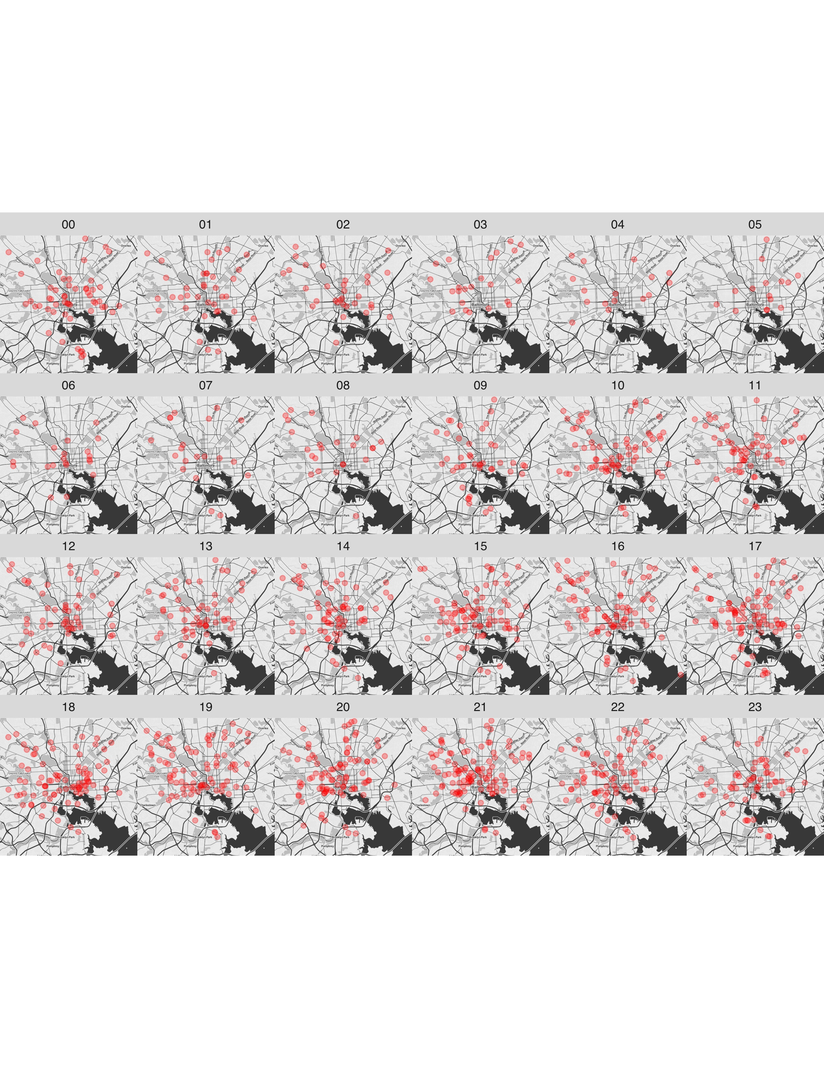 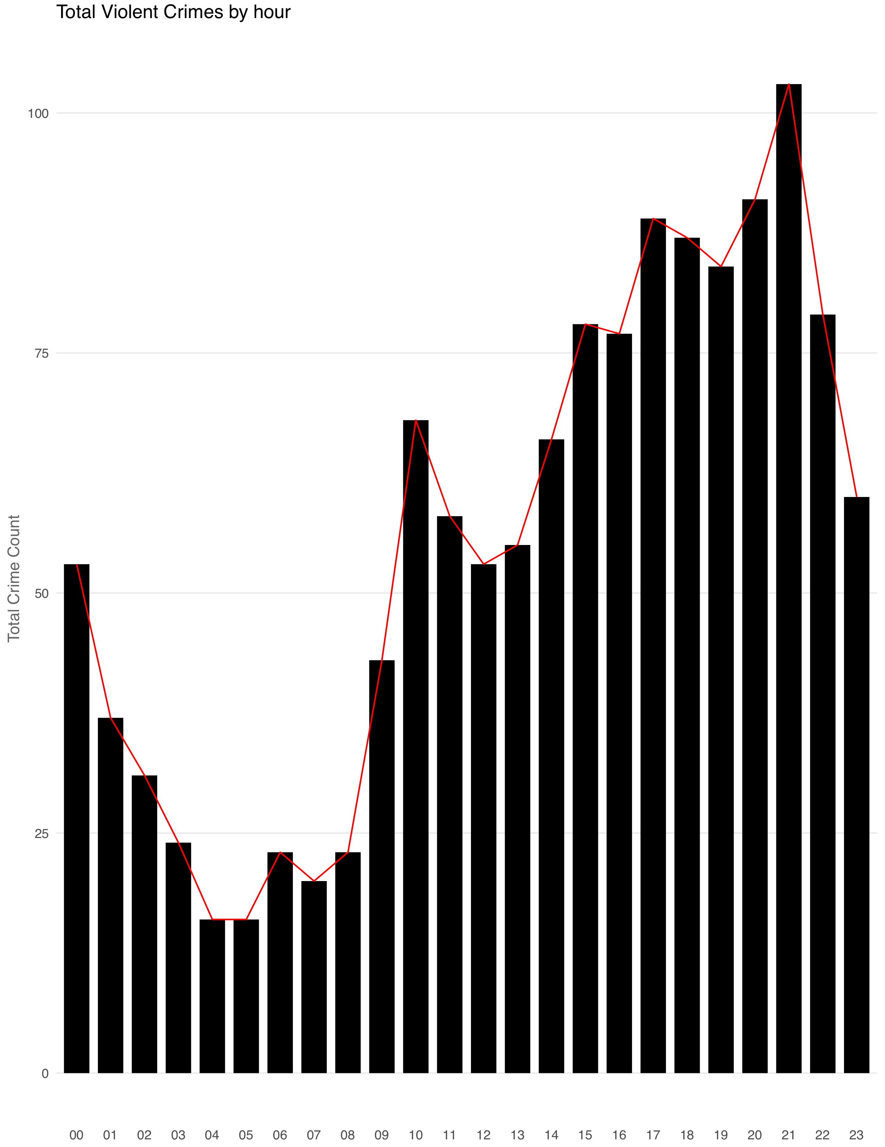

***(frequency of the violent crime in each hour)***

Crime frequency:

High(relatively): 3pm-10pm

Low(relatively): 1am-8am

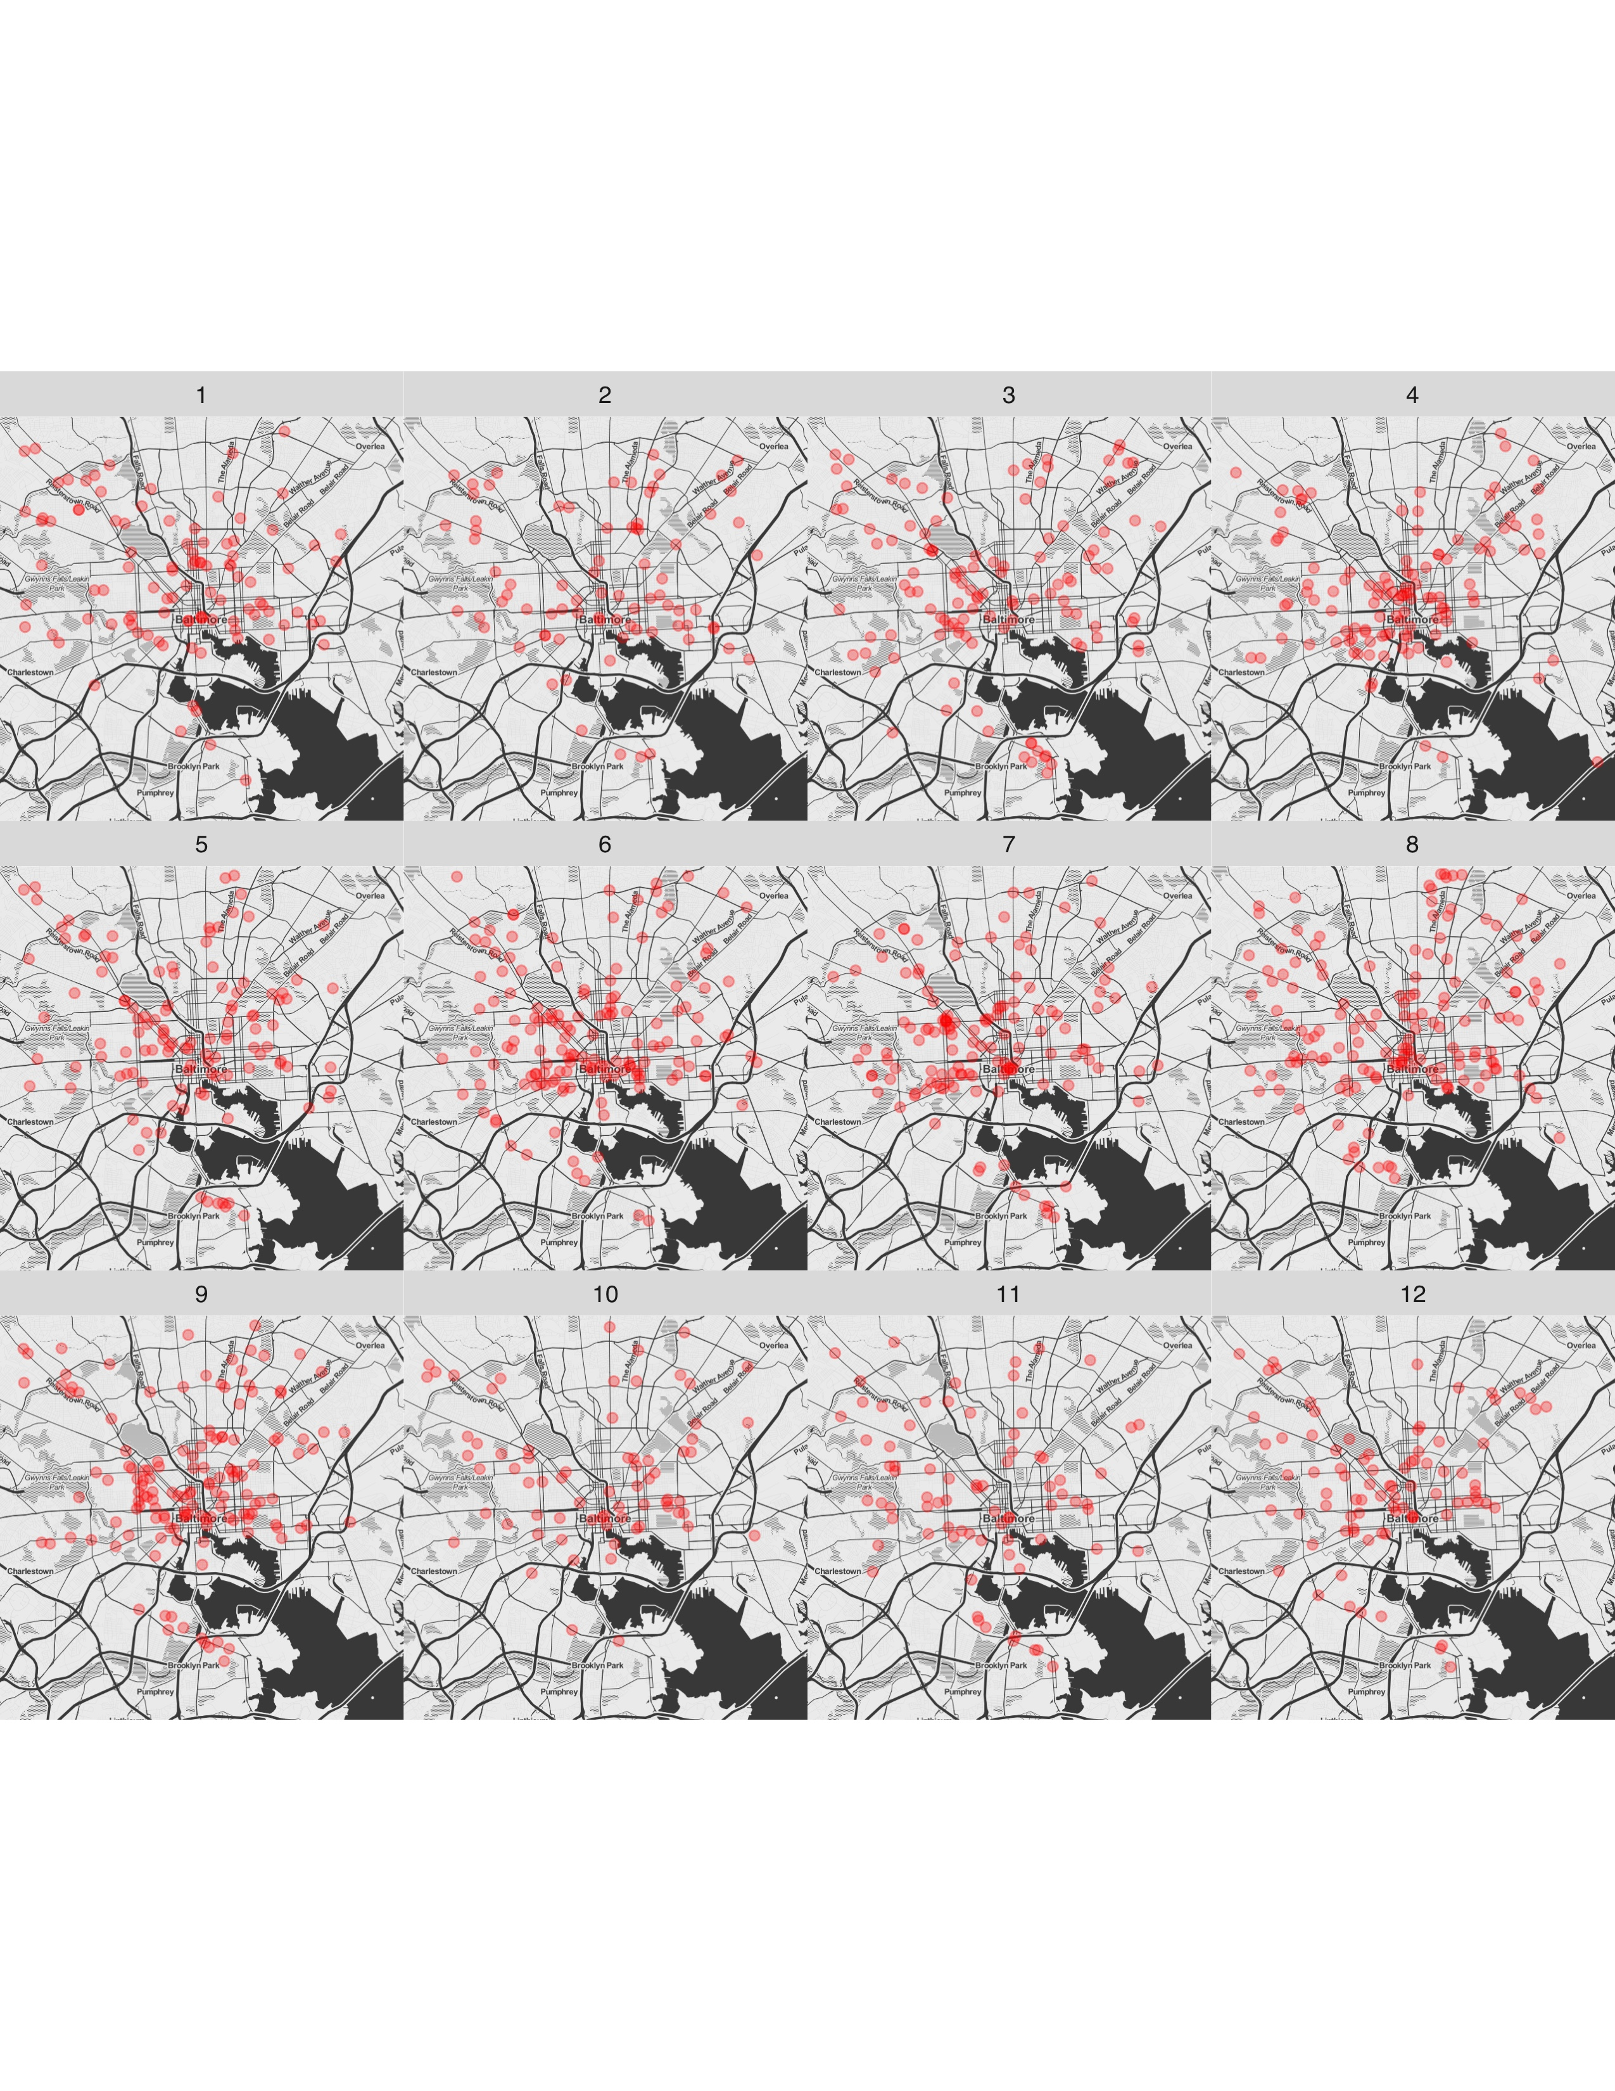 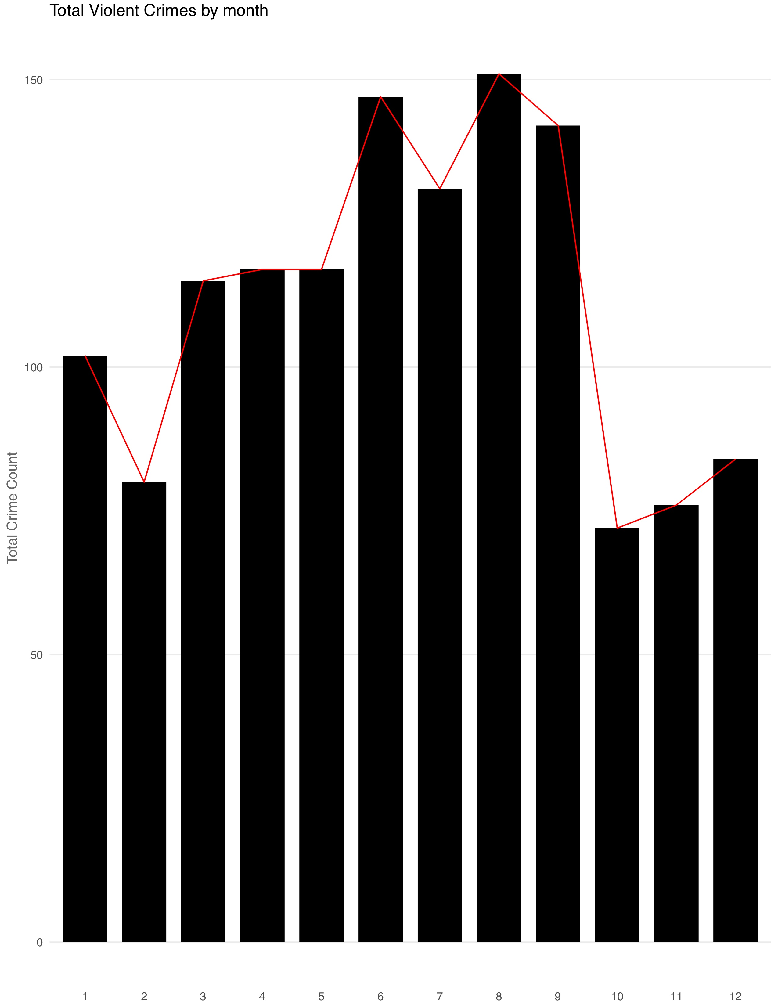

***(frequency of violent crime in each month)***

Crime frequency:

High(relatively): Mar-Sep

Low(relatively): Oct-Dec

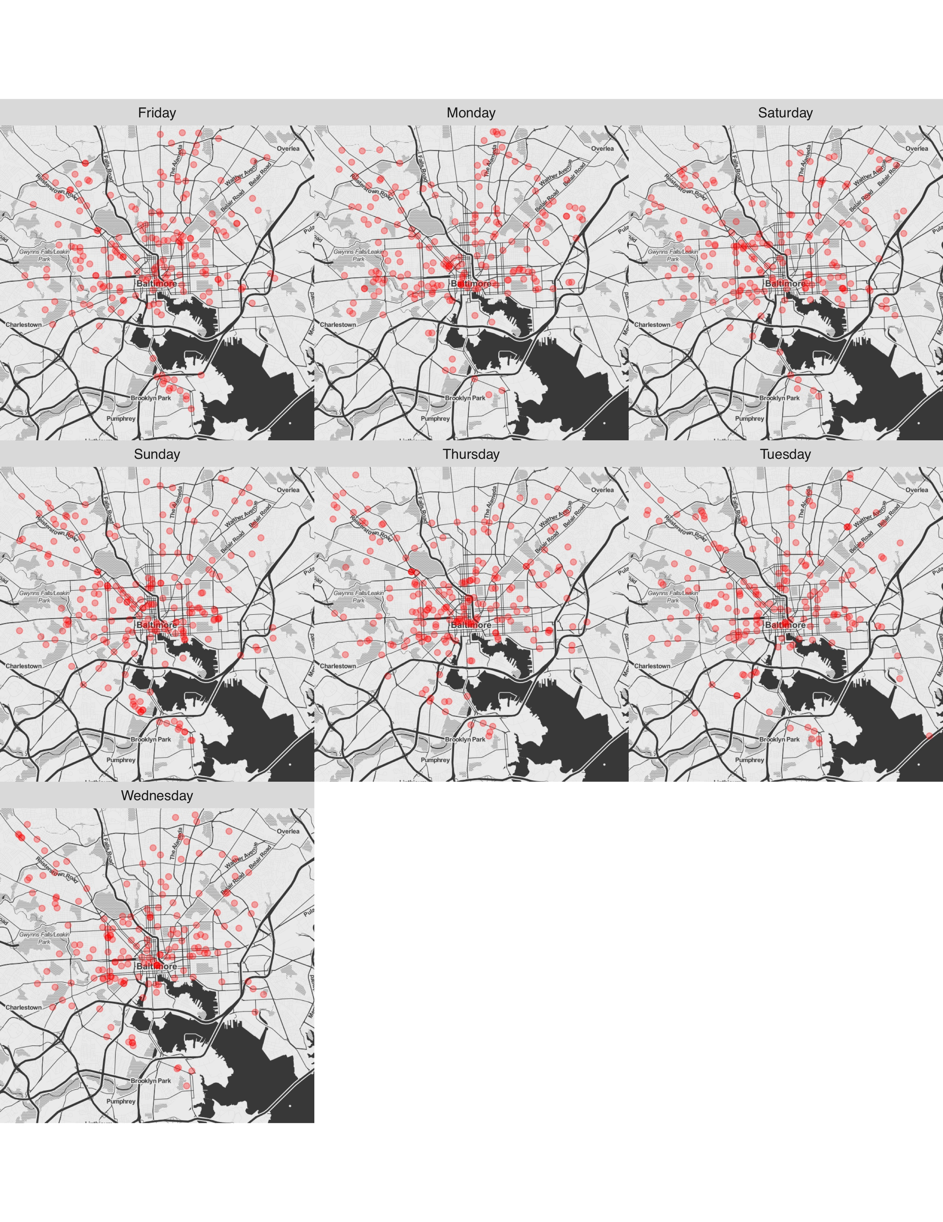 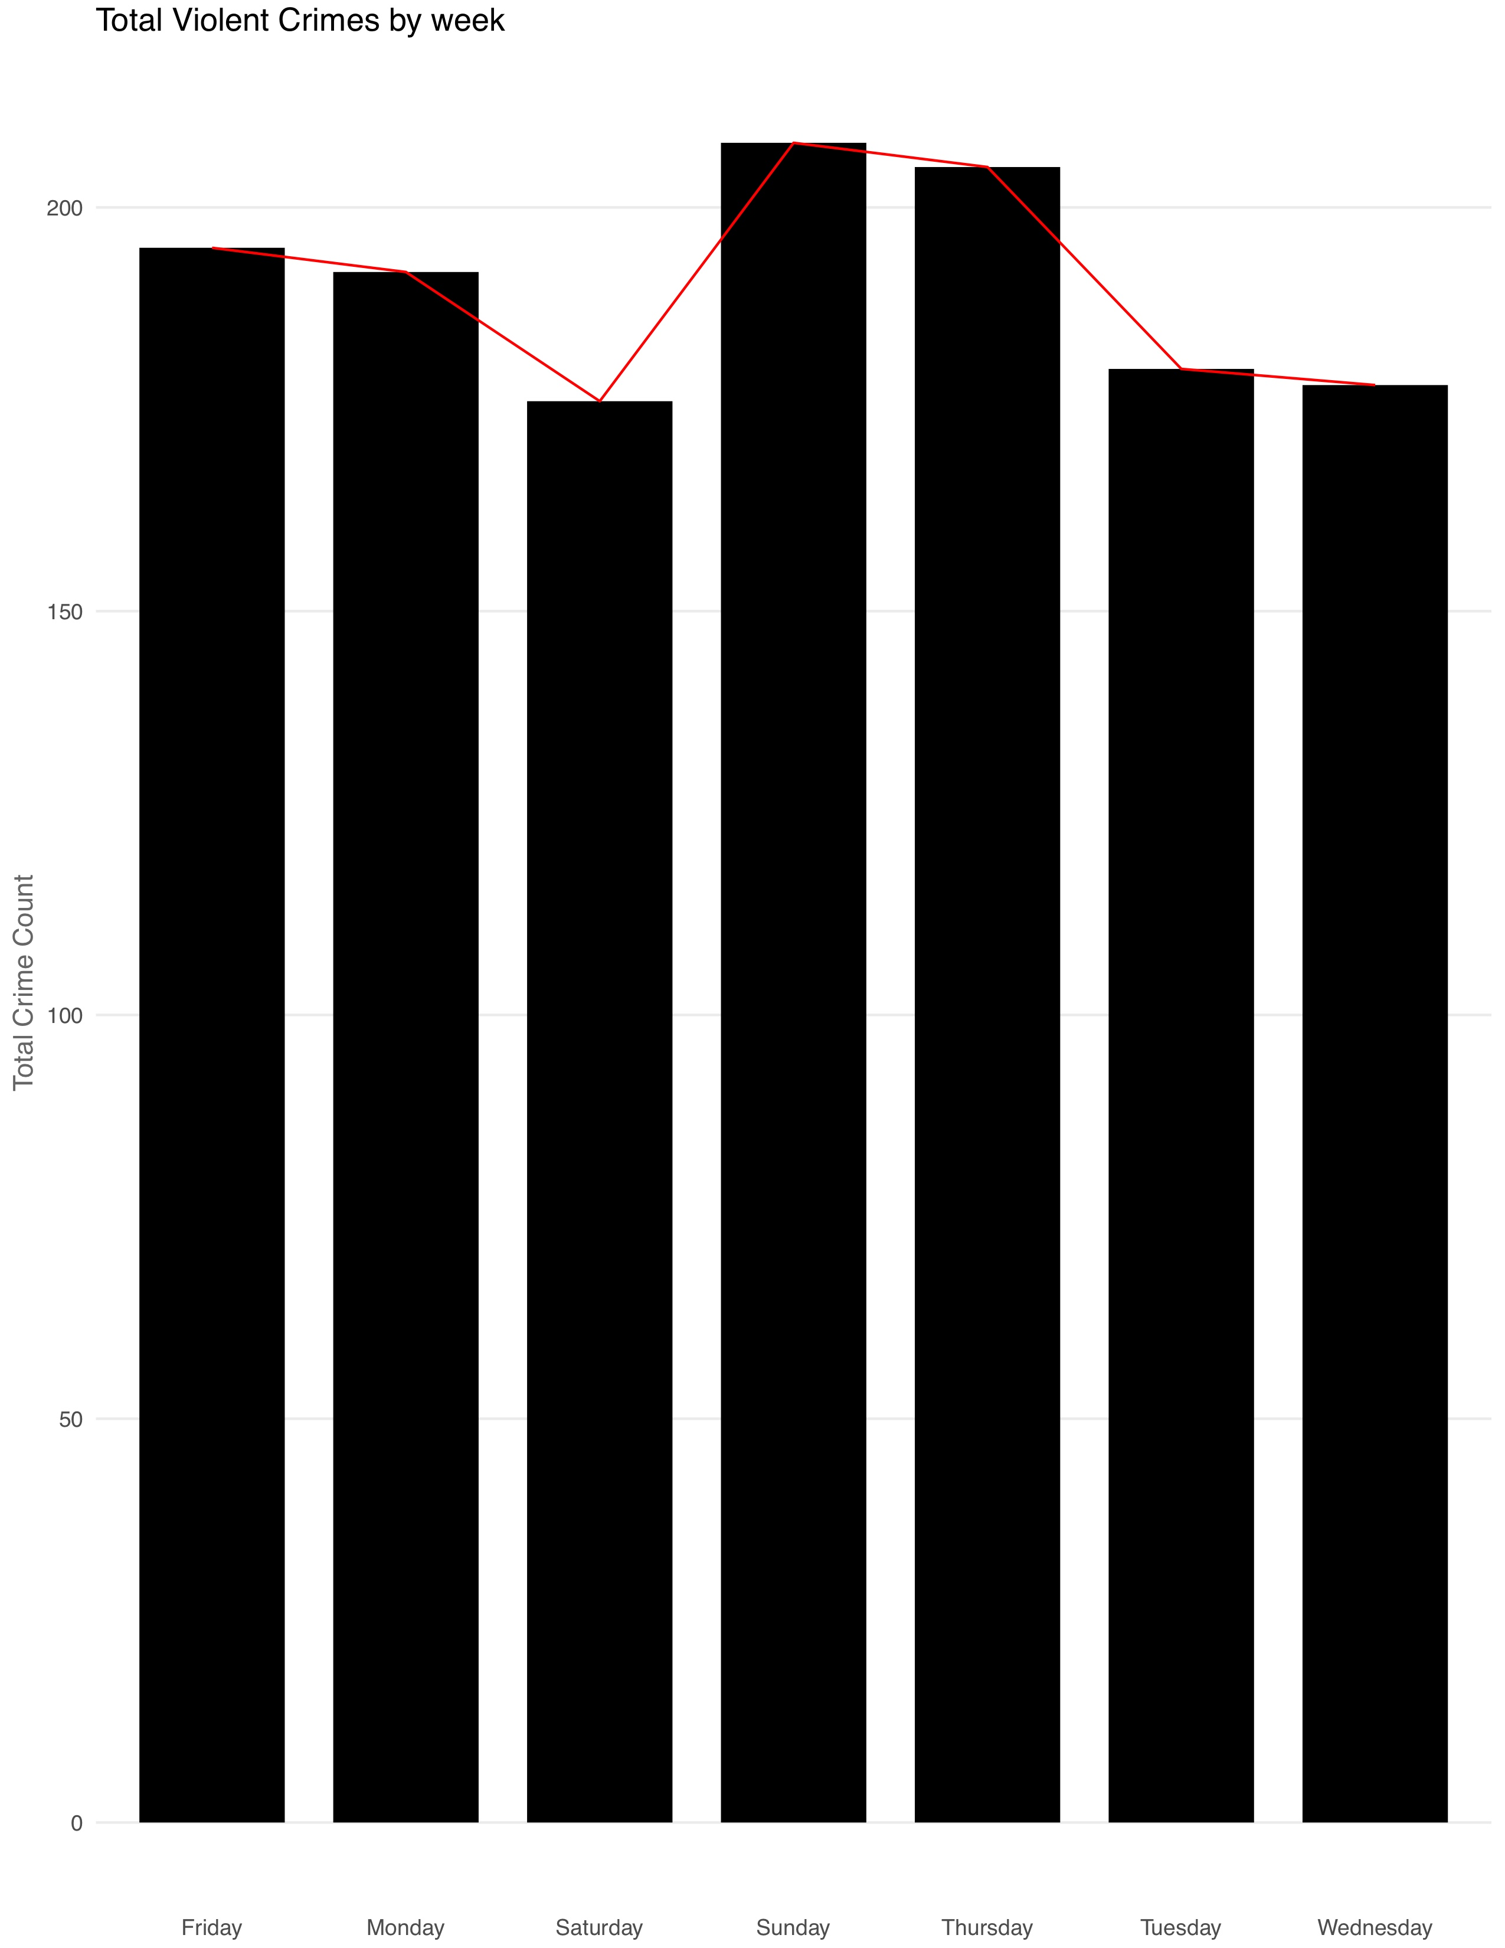

***(frequency of violent crime in each weekday)***

The frequency of violent crime is relatively high in Sunday, Thursday and Friday.

***Pie charts***

